NEXTBOT PLATFORM
Target Architecture and
Enhancement Blueprint

A senior-architecture review of the NextBot conversational AI platform, a gap analysis against the current screen inventory, and the detailed design of six new or restructured modules: the MCP Definition Registry, the Knowledge and Graph RAG subsystem, Skills and the Agent Design Studio, the Workflow Designer, Multi-agent Orchestration, and Model Gateway v2.
Includes suggested wireframes for every new screen.
Field | Value
Document | NextBot — Target Architecture and Enhancement Blueprint
Version | 1.0
Status | For architecture review
Date | 28 August 2026
Basis | NextBot — Screen Reference (live seeded instance)
Audience | Platform engineering, product, security, and delivery leadership
Scope | Admin Console, Agent Platform, Platform Manager console, customer widget

Contents

1. Executive summary
NextBot today is a well-built tenant-facing conversational AI console with an unusually disciplined security posture. Access control fails closed at every screen, agent versions are immutable, promotion to production requires a passing eval run plus an approver who is not the author plus a real sandbox conversation, and high-risk tool calls stop at a human approval queue. These are the right foundations and this document treats them as constraints, not as things to be redesigned.
The platform is, however, missing several subsystems that its own architecture implies. It has no knowledge layer, so an agent can only reach information through an MCP tool call. It has no way to manage the MCP servers it depends on beyond a connection form, so a server that changes its tool schemas can silently change agent behaviour in production. It has no reusable unit of agent capability, so every agent version is authored from scratch. It has no orchestration, so a channel talks to exactly one agent. And its model gateway treats a model as a free-text string typed into a form, which is untenable across the provider landscape the platform will need to support.
This document proposes six modules that close those gaps while preserving the platform's existing guarantees:
Module | Status today | Proposal
MCP Definition Registry | Partially exists as /connectors — a connection form with health | Promote to a governed enrolment lifecycle with pinned manifests, drift quarantine, capability groups, and per-environment binding
Knowledge and Graph RAG | Absent entirely | A graph-indexed knowledge subsystem with entity and relation extraction, community summarisation, three retrieval strategies, and a bounded retrieval agent
Skills and Agent Design Studio | Text mode and Design mode exist; no reusable unit | Skills as a first-class versioned artifact, plus a guided studio that composes them into the same immutable YAML
Workflow Designer | Absent entirely | A versioned orchestration graph, authored as YAML, promoted through the existing gate
Multi-agent Orchestration | Absent entirely | Supervisor and specialist teams, where a specialist is registered as a tool so delegation inherits tiering, permissions, and audit
Model Gateway v2 | Routes plus a read-only provider list; model names are typed strings | A three-layer provider / model catalogue / route model spanning Anthropic, OpenAI, Google, OpenRouter, Azure, Bedrock, vLLM, Ollama and any OpenAI-compatible endpoint

Three of these changes are load-bearing for the others. Model Gateway v2 must land before the knowledge subsystem, because a knowledge index pins an embedding model and cannot do so against a free-text string. Skills must land before the Studio, or the Studio is only a longer form. And version pinning — of MCP manifests, skills, model routes, and agent versions — must be designed in from the first line of code, because retrofitting it means auditing every artifact already in production.
The single most important rule in this document
Every new artifact is versioned, immutable once promoted, and pins the version of everything it references.
A skill, an MCP manifest, a model route, or a member agent that can change underneath a promoted agent version destroys the platform's strongest existing property: that what is running in production is exactly what was reviewed.

2. Scope and method
This review is based on the NextBot Screen Reference, a screen-by-screen description of the live seeded platform covering the authentication screens, the tenant Admin Console, the Agent Platform, tenant Settings, the cross-tenant Platform Manager console, and the customer-facing widget.

2.1 What is in scope
- The tenant-facing Admin Console and Agent Platform, where the six proposed modules live.
- Cross-cutting concerns that the new modules touch: permissions, PII handling, audit attribution, observability, cost, and data residency.
- The data model additions each module requires.
- Suggested wireframes for every new screen, included inline and indexed in Appendix A.

2.2 What is out of scope
- The customer-facing widget's visual design, beyond the requirement that it render citations produced by the knowledge subsystem.
- Platform Manager console changes, other than the plan-tier controls needed to govern which provider types a tenant may use.
- Commercial packaging, pricing, and contractual data-processing terms.
- Detailed API contracts, which follow once the module boundaries in this document are agreed.

2.3 How to read the module sections
Sections 6 to 11 follow a consistent shape: what exists today and why it is insufficient, the proposed screens, the domain model, the rules the runtime must enforce rather than the UI, and the wireframes. Where a rule appears in a highlighted box, it is a rule that cannot be delegated to prompt instructions or to the interface — it has to be enforced by the platform, or it is not enforced at all.

3. Current platform baseline

3.1 Screen inventory
The following inventory is derived from the Screen Reference. Module names in the third column are the permission modules that gate each screen, read/write/none per role.
Area | Screens | Permission module
Authentication | Login with tenant slug, TOTP MFA and backup codes; forgot password with non-enumerable response; separate Platform Manager login behind an operator token and IP allowlist | —
Operations | Dashboard with conversation volume, escalation rate and tool-call activity | reporting
Operations | Conversations list and detail, with transcript, collapsible reasoning trace and tool calls | conversations
Operations | Approval Queue for Tier-3 tool calls awaiting a human decision | approval_queue
Operations | Escalation Queue and live takeover panel | escalations
Operations | Channels list, add-channel type picker, per-type setup, and an in-console channel test running the deployed Production version | channels
Integration | Connectors list, add form and detail with live health | connectors
Integration | Tool Catalog with read/write class and approval tier; per-tool permission rules with a simulate preview | tool_permissions, agent_tool_config
Integration | MCP Health with a health tab and an alert configuration tab | connectors
Agent Platform | Agent definitions and versions; create/edit a version in Text or Design mode; version detail with Overview, Eval and Sandbox tabs; eval suites; model gateway; runtime traces; Git-backed diff | agent_platform
Settings | Settings hub, branding and white-label, escalation routing, Git integration, PII and guardrails, retention and residency, data subject requests | security_settings, escalations, agent_platform
Administration | Users and roles with the permission matrix editor; audit log with actor attribution | users_roles, audit_log
Platform Manager | Tenant list, detail and provisioning; plan tiers; cross-tenant connector health rollup | operator token

3.2 Architectural invariants worth preserving
These are the decisions that constrain every proposal in this document. Each one is currently honoured consistently, and each one is easy to break accidentally when adding the modules below.
Invariant | How it manifests today | Risk introduced by the new modules
Fail closed | A role without access sees an explicit no-access state on a direct link. Settings hub cards are hidden per role. Unconfigured masking-context combinations default to full masking. The Platform Manager console is indistinguishable from a missing page. | New screens and new node types must inherit the same default-deny posture rather than defaulting to visible.
Immutable versions | Agent versions never change after creation. Restore authors a new version pre-filled from an old one rather than mutating it. | Skills, routes and team members referenced by name rather than by version would silently mutate a promoted version.
The promotion gate | Production requires a passing eval run, an approver who is not the author, and at least one completed sandbox conversation. | Wizards, workflows and teams must all land in Draft and pass the same gate. None may bypass it.
Tool tiering | Tier 1 runs automatically, Tier 2 is logged, Tier 3 stops at the Approval Queue. | A Tier-3 tool invoked from inside a workflow node or a delegated sub-agent must still stop at the queue.
Credentials never returned | Connector credentials are stored in an encrypted vault and never shown back in plaintext once saved. | Provider credentials in Model Gateway v2 and MCP enrolment must use the same vault, not a new store.
One widget artifact | The customer widget is a standalone application reused for the channel test and the version sandbox, so what is tested is what customers get. | Team and workflow sandboxes must reuse the same widget rather than introducing a lighter mock.
Separate audit trails | Every Platform Manager mutation writes to a platform-level audit trail, separate from any tenant's own log. | Multi-agent runs must extend tenant audit attribution to a delegation chain rather than logging a bare agent name.

4. Gap analysis
Gaps are rated by the risk they carry today, not by implementation effort. Severity 1 means an incident is likely and recovery is currently slow or impossible; severity 2 means a capability the platform is expected to have is absent; severity 3 means an operational or commercial limitation.
ID | Gap | Consequence | Sev | Addressed in
G-01 | No knowledge or retrieval layer of any kind | An agent can only reach information through a tool call. No document grounding, no citations, no content-coverage reporting. | 1 | §7
G-02 | No rollback path | Promotion replaces the prior production deployment. Restoring an older version creates a new version that must re-pass the full gate, so recovery is slower than causing the outage. | 1 | §14
G-03 | MCP manifests are not pinned | A server that adds a tool or changes an approved tool's input schema changes agent behaviour with no review and no alert. | 1 | §6
G-04 | No guardrail on tool output | A Fetch-class connector returns attacker-controlled text straight into the model context. Injection is currently unguarded, and will propagate across agents once delegation exists. | 1 | §12.2
G-05 | Model is a free-text string | No capability metadata, no price, no context window, no deprecation signal. A version can be saved that requests tool calling from a model that does not support it, failing only at runtime. | 1 | §11
G-06 | Capability groups are referenced but unauthorable | Design mode offers a picker for Tool Registry capability groups, but no screen anywhere creates or edits them. | 2 | §6.3
G-07 | Diff requires a Git commit on both versions | Versions can be authored without Git, so the majority path has no diff at all on a platform whose core artifact is a YAML document. | 2 | §8.5
G-08 | Evals are pre-deployment and hand-authored only | No harvesting of production conversations into cases, no continuous run against production to catch provider drift, no LLM-judge grading, no regression baseline. | 2 | §8.4
G-09 | No reusable unit of agent capability | Every version is authored from scratch; eval cases are written separately from the behaviour they test. | 2 | §8
G-10 | A channel talks to exactly one agent | No orchestration, no specialist routing, no deterministic branching, no long-running process. | 2 | §9, §10
G-11 | No tenant-facing cost or usage view | Quotas exist only in the Platform Manager console. A tenant cannot see spend by agent, route or model, and learns about a limit when it is hit. | 2 | §11.6
G-12 | No SSO or SCIM | Password plus TOTP only, on a platform sold with an Enterprise tier, residency controls and a DSR screen. Blocks enterprise procurement independent of product quality. | 2 | §12.6
G-13 | No public API or webhooks | Everything is console-driven. NextBot can call out to systems; systems cannot drive NextBot. | 2 | §12.6
G-14 | Escalation queue lacks workforce mechanics | No assignment, SLA timers, agent presence, concurrency limits or CSAT capture. Routing to an unwatched queue is silent failure. | 2 | §12.5
G-15 | Observability stops at the tenant boundary | No OpenTelemetry export, no SIEM streaming of the audit log, no synthetic monitoring. The operator health rollup is deliberately metadata-only, leaving no consented path to diagnose a tenant quality regression. | 3 | §12.4
G-16 | Two channel types, no cross-channel identity | The same customer on WhatsApp and web is two unrelated conversations with no shared context. | 3 | §12.5
G-17 | No configuration export or restore | Retention and Residency covers purge and region, not recoverability. There is no backup of a tenant's agent, connector and policy configuration. | 3 | §12.4
G-18 | One Git connection per tenant | Caps a large tenant at a single repository across all teams and agent definitions. | 3 | §8.5

5. Target architecture

5.1 The composition model
The six modules are not independent features. They form a chain in which each layer is a versioned artifact that pins the layer beneath it. Reading upward: MCP servers expose tools and resources; capability groups curate those tools into named sets; skills bundle a capability with the tools, knowledge and eval cases it needs; an agent version composes skills; a workflow or a team composes agent versions; and a channel binds to one workflow, team or agent version.
Layer | Artifact | Pins | Versioned | Promoted through the gate
1 | MCP server definition | Endpoint, credential, manifest hash | Yes | No — reviewed at enrolment and on drift
2 | Capability group | A set of tool identities | Yes | No
3 | Knowledge collection | Sources, embedding model, index build | Yes (index generation) | No
4 | Skill | Tools, capability groups, knowledge scopes, eval cases | Yes | No — validated, not promoted
5 | Agent version | Skills, model routes, knowledge scopes, guardrails | Yes, immutable | Yes
6 | Workflow version / Team version | Agent versions, skills, tools, sub-workflows | Yes, immutable | Yes
7 | Channel binding | One production workflow, team or agent version | Deployment record | Deployment action

5.2 New and changed permission modules
The platform gates screens by permission module, read/write/none per role. The proposal adds four modules and re-scopes one, keeping the existing split whereby seeing a configuration and changing it can be granted separately.
Module | New or changed | Gates
mcp_registry | New | Server enrolment, manifest review, drift acceptance, capability group management
knowledge | New | Collections, sources, ingestion pipeline, graph explorer, retrieval playground
knowledge_config | New | Which embedding and rerank models a collection uses, chunking and extraction policy — separated so a curator can add sources without changing retrieval behaviour
workflows | New | Workflow and team definitions, canvas, run history
agent_platform | Changed | Now also gates skills and the Agent Design Studio; model gateway remains under it

5.3 Design principles applied throughout
- The YAML is the artifact. Every authoring surface — Design mode, the Studio wizard, the workflow canvas, the team editor — is a renderer over a YAML document validated by one validator. No surface may express something the schema cannot, and no surface may bypass validation.
- Every reference is version-pinned at compose time. Names are for humans; the stored artifact records skill@3, server@7, route@12, agent@9.
- Permissions compose by intersection, never union. Delegation, composition and orchestration may narrow scope. They may never widen it.
- Tenant policy can be tightened by an artifact, never loosened. An agent version that relaxes tenant PII masking fails validation rather than being blocked only in the interface.
- Reuse the existing control surfaces. Human decisions go to the Approval Queue or the Escalation Queue. Delegation goes through the Tool Catalog. New queues and parallel permission systems are how governance drifts out of sync.
- Cost, latency and depth are enforced by the runtime. Budgets written into a system prompt are advisory; budgets enforced by the executor are real.

6. Module A — MCP Definition Registry

6.1 What exists today and why it is insufficient
The Connectors screens handle the operational concern well: a form captures name, description, backend type, environment, transport (streamable HTTP or a gateway-mediated stdio process), endpoint URL and an authentication method, with the credential itself held in the encrypted vault and never returned in plaintext; the detail page shows live health. The Tool Catalog then lists every tool discovered across every connector, tagged with a read/write classification and an approval tier, with per-tool allow and deny rules and a simulate preview.
That is a connection manager. It is not an enrolment lifecycle, and four things are missing as a result.
Missing | Consequence
No pinned manifest | There is no recorded snapshot of what a server exposed at the moment it was approved, so there is nothing to compare against. A server that adds a tool, removes one, or changes an approved tool's input schema changes what agents can do with no review and no alert. This is the clearest privilege-escalation path in the platform today.
Only tools are modelled | MCP servers expose tools, resources and prompts. Resources are the natural feed into the knowledge subsystem in §7 and are currently discarded.
Capability groups are unauthorable | Design mode offers a picker for Tool Registry capability groups such as "Knowledge and Web" or "DevOps and Code", but no screen creates, edits or audits them.
No environment binding | One logical server with development, staging and production endpoints is three unrelated connector rows with three unrelated tool lists and three unrelated health histories.

6.2 Proposed screens
Route | Purpose
/mcp/servers | Registry list: server, transport, environments bound, tool count, manifest state and health
/mcp/servers/new | Nine-step enrolment wizard
/mcp/servers/[id] | Definition detail — tabs for Manifest, Tools, Resources, Prompts, Policy, Environments, Versions and Health
/mcp/servers/[id]/drift | Diff of the live manifest against the pinned manifest, with an accept or reject review
/mcp/capability-groups | Create and edit the groups consumed by the Design mode and Studio pickers

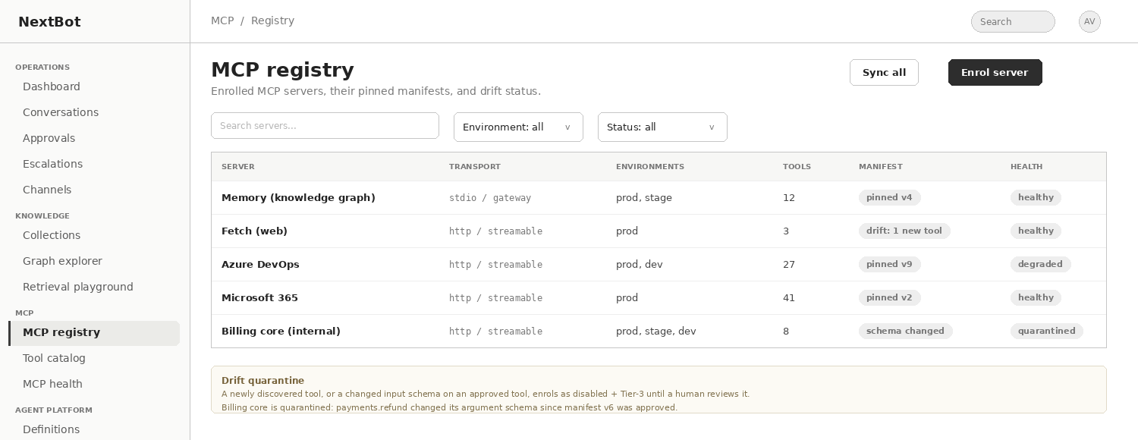
Figure 1 — MCP registry list. Manifest state is a first-class column: pinned, drifting, or quarantined.

6.3 The enrolment wizard
- Identify — name, description, owner, backend type, business criticality.
- Transport and endpoint — streamable HTTP or gateway-mediated stdio, with a separate endpoint per environment rather than a separate connector per environment.
- Authentication — method plus credential, written straight to the existing encrypted vault. Sandbox and production credentials are captured separately so that version sandbox testing never reaches live systems.
- Discovery handshake — connect, enumerate tools, resources and prompts, capture the JSON schemas, and hash the whole response into a pinned manifest.
- Classification — read or write, and approval tier, per tool. Pre-filled by a heuristic over the tool schema and description, confirmed by a human. Anything unclassified defaults to Tier 3 and disabled.
- Grouping — assign tools to capability groups.
- Runtime policy — timeout, retry, circuit-breaker threshold, per-tool rate limit, cost attribution tag and egress allowlist.
- Dry run — invoke one read-only tool against the sandbox credential and show the raw result before anything is enrolled.
- Enrol — writes the definition and the manifest hash to the audit log.
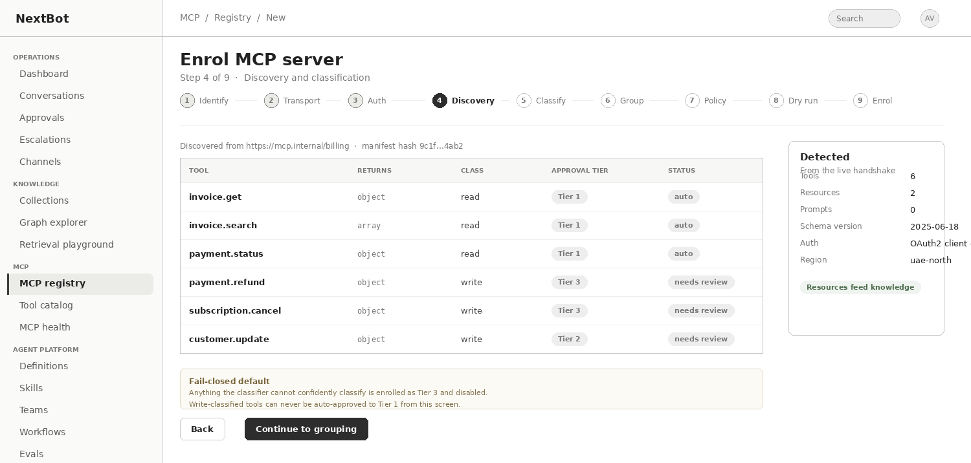
Figure 2 — Enrolment wizard, discovery and classification step. Write-classified tools cannot be auto-approved to Tier 1 from this screen.

6.4 Rules the runtime must enforce
Manifest pinning and drift quarantine
A reconciler re-fetches each server's manifest on a schedule and compares it to the pinned hash.
A newly appeared tool enrols as disabled and Tier 3 until a human reviews it.
A changed input schema on an already-approved tool is treated as a new tool, not as an update — because that is exactly the vector by which a compromised or updated server escalates its own privileges.
An agent version records the server definition version it was validated against, so drift surfaces as a warning on the agent rather than as changed behaviour in production.

- Server definitions are versioned and immutable, so an agent version can pin server@definitionVersion and be reproducible.
- Resources discovered on a server are offered as ingestion candidates to the knowledge subsystem rather than being discarded.
- Health, alerting and error classification remain where they are today, on the MCP Health screen; the registry links to it rather than duplicating it.

6.5 Data model additions
Entity | Key fields
mcp_server | id, tenant_id, name, backend_type, criticality, owner, status, created_by
mcp_server_version | id, server_id, version, transport, auth_method, credential_ref, policy_json, manifest_hash, approved_by, approved_at
mcp_environment_binding | id, server_version_id, environment, endpoint_url, credential_ref, reachable_at
mcp_manifest_item | id, server_version_id, kind (tool|resource|prompt), name, schema_json, schema_hash, io_class, approval_tier, enabled
mcp_drift_event | id, server_id, detected_at, change_kind, item_name, old_schema_hash, new_schema_hash, resolution, resolved_by
capability_group | id, tenant_id, name, description
capability_group_item | group_id, server_id, tool_name

7. Module B — Knowledge and Graph RAG

7.1 Why a graph, and not only a vector index
The largest structural gap in the platform is that there is no knowledge layer at all. The only route to information is an MCP tool call, which means a tenant cannot upload a policy document and have an agent ground its answers in it, the conversation detail view has no citation panel, and there is no reporting on what customers asked that the tenant has no content for.
Plain vector retrieval solves part of this and fails on the questions support agents are actually asked. A question such as "can a customer dispute a charge after the refund window closes" depends on a relationship between three concepts — the dispute window, the chargeback rule and the refund policy — that never appear together in a single chunk. Top-k similarity returns chunks about each concept and the model is left to infer a connection it was never shown.
A graph index fixes this by extracting entities and the relations between them at ingestion time, so retrieval can walk from an anchor entity to its neighbours and return the relation path itself as evidence. It also enables a second retrieval mode that vector search cannot offer at all: summarising an entire thematic community of the graph to answer broad questions such as "what does our refund policy actually cover".

7.2 Ingestion pipeline
Stage | What happens | Notes
Ingest | Files, crawled URLs, MCP resources from the registry, or connector syncs | Source ACLs are captured here and carried through to every chunk
Parse | Text, tables and layout extraction; OCR where needed | Tables are preserved as structured blocks, not flattened to prose
Chunk | Semantic chunking with configurable size and overlap | Chunk provenance records document, page and section
Extract entities | An LLM pass produces entities, types, relations and claims per chunk | Runs on a cheap route — see §11; this is the dominant ingestion cost
Resolve | Canonicalisation and deduplication of entity mentions across documents | Deterministic rules plus embedding similarity, with a human review queue for low-confidence merges
Build graph | Nodes, typed edges and provenance written to the graph store | Every edge keeps the chunk it came from
Community detection | Hierarchical clustering of the graph into thematic communities | Leiden or equivalent; communities are what global retrieval summarises
Community summaries | A summary is generated per community at each level | Regenerated incrementally when member entities change
Embed | Chunks, entity summaries and community summaries are embedded | Embedding model is pinned to the index generation
Index | Vector index plus graph store, region-pinned per tenant | Honours Settings > Retention and Residency

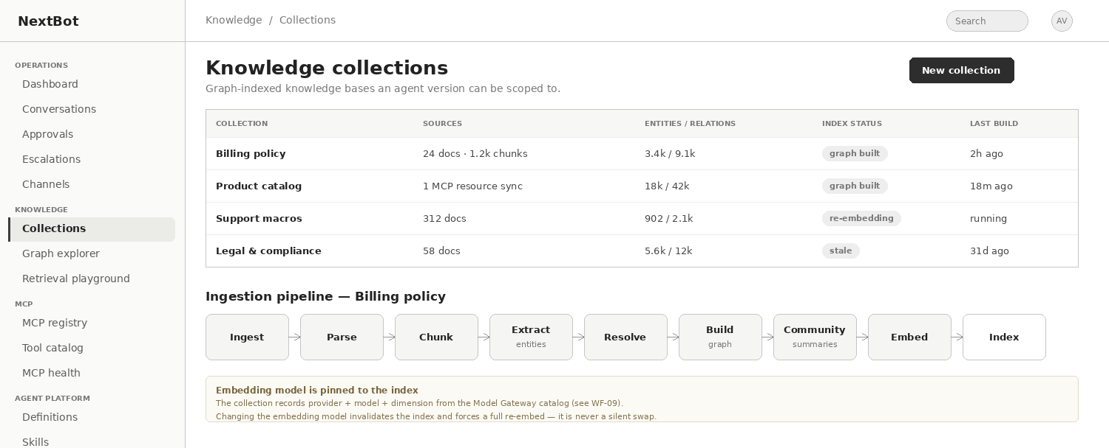
Figure 3 — Knowledge collections with the ingestion pipeline for one collection. Index status distinguishes built, re-embedding and stale.
The embedding model is part of the index, not a setting
A collection records provider, model and dimension from the Model Gateway catalogue at build time.
Changing the embedding model invalidates the index and forces a full re-embed. It is never a silent swap, and the screen must say so before the change is accepted.
This is the dependency that makes Model Gateway v2 a prerequisite for this module rather than a parallel workstream.

7.3 The graph explorer
Curators need to see what was extracted, because extraction quality is the single largest determinant of retrieval quality and it is invisible in a pure vector system. The explorer shows entities, their relations, the community they belong to and — critically — the provenance of every relation, so a wrong answer can be traced to the sentence that produced the wrong edge.
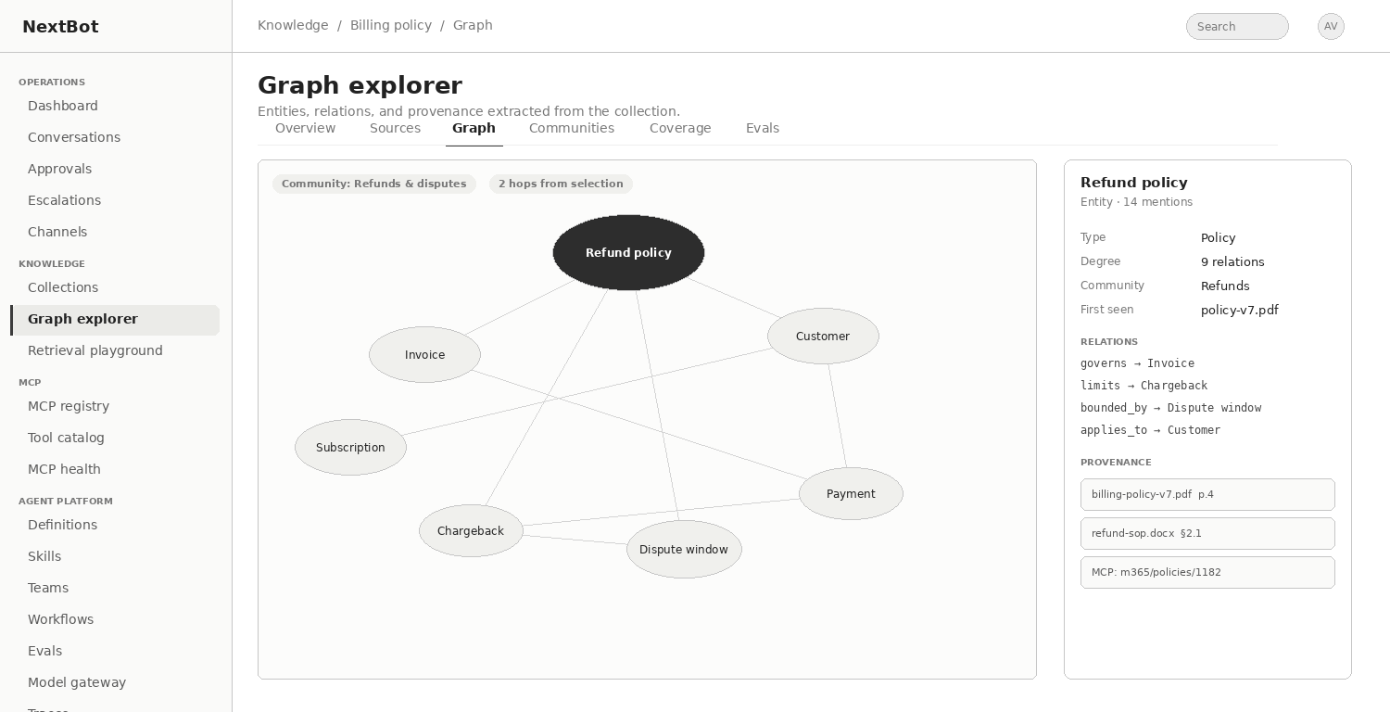
Figure 4 — Graph explorer with an entity inspector. Every relation carries provenance back to the source chunk.

7.4 Retrieval strategies
Strategy | How it works | Best for | Relative cost
Vector | Top-k similarity over chunk embeddings | Lookup questions answered by a single passage | Lowest
Graph local | Anchor on entities mentioned in the query, walk N hops, return neighbour chunks plus the relation path | Questions whose answer spans related concepts | Low to medium
Graph global | Map over community summaries, reduce to an answer | Broad, thematic or "what does our policy cover" questions | Highest
Hybrid | Vector recall, then graph expansion of the top entities, then rerank | Default when the query classifier is uncertain | Medium

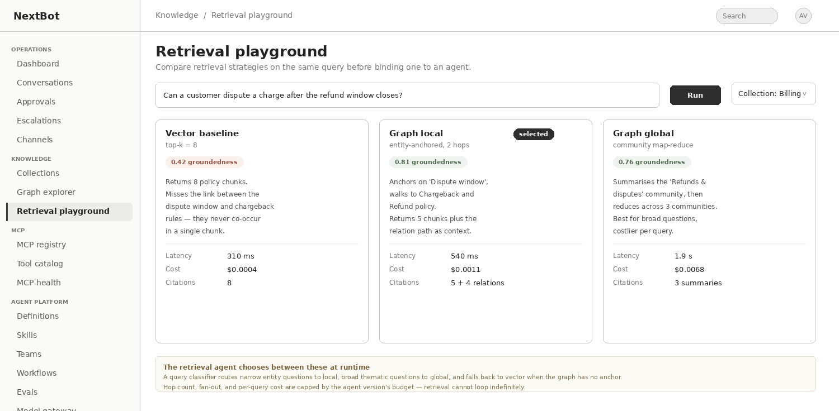
Figure 5 — Retrieval playground comparing three strategies on one query, with groundedness, latency and cost per strategy.

7.5 The retrieval agent
Retrieval is not a single call. An effective retrieval agent plans, retrieves, assesses whether what it has is sufficient, expands if not, and answers with citations — bounded so that it cannot loop.
Retrieval configuration, expressed in the same version YAML as everything else.
kind: agentVersion
name: retrieval_agent
modelRoute: chat.primary # answering
plannerRoute: chat.router # classification and sufficiency checks
knowledge:
collections: [billing_policy@12, legal@4]
strategy: auto # vector | local | global | hybrid | auto
maxHops: 2
maxExpansions: 3
minCitations: 1
refuseWhenUngrounded: true
budget:
usdPerTurn: 0.02
seconds: 8

- Query classification chooses the strategy: narrow entity questions go local, broad thematic questions go global, and anything without a graph anchor falls back to vector.
- A sufficiency check after each retrieval decides whether to expand another hop or answer. Expansion is capped, so retrieval cannot loop indefinitely.
- refuseWhenUngrounded is the single most valuable setting in this block. An agent that says it does not know is worth more than one that fills the gap, and this is enforced by the runtime rejecting an answer with no citations, not by asking the model nicely.
- Citations are returned as structured references — collection, document, chunk and, for graph retrieval, the relation path — and rendered in Conversations, Runtime Traces and the customer widget.

7.6 Governance
Concern | Rule
Access control | Source ACLs are captured at ingestion and carried to every chunk, entity and edge. Retrieval filters by the requesting agent's scope before ranking, never after. A chunk the caller may not see must not influence the ranking of chunks it may.
PII | Tenant PII detection rules run at ingestion. Detected entities are masked at index time according to the masking-context matrix for the collection's trust level, and re-evaluated at read time for the requesting agent's trust level.
Residency | The index, the graph store and the embedding provider must all satisfy the tenant's storage region and out-of-region inference setting. A route that would send chunks out of region is rejected at collection configuration time.
Retention | Collections inherit the tenant retention policy. A purged source removes its chunks, its extracted entities where they have no other provenance, and triggers community re-summarisation.
Freshness | Incremental re-ingestion with delta entity resolution. Collections show a staleness badge; an agent version can declare a maximum acceptable staleness and refuse rather than answer from a stale index.
Coverage | A coverage tab reports questions asked in production that retrieved nothing above threshold — the content backlog, generated from real demand rather than guessed.

7.7 Data model additions
Entity | Key fields
knowledge_collection | id, tenant_id, name, region, retention_days, trust_level, status
knowledge_source | id, collection_id, kind (upload|url|mcp_resource|connector), locator, acl_json, last_synced_at
knowledge_index_generation | id, collection_id, generation, embedding_provider_id, embedding_model_id, dimension, built_at, status
knowledge_chunk | id, generation_id, source_id, ordinal, text, acl_json, pii_mask_json, vector_ref
graph_entity | id, generation_id, canonical_name, type, summary, community_id, degree
graph_edge | id, generation_id, src_entity_id, dst_entity_id, relation, weight, provenance_chunk_id
graph_community | id, generation_id, level, parent_id, title, summary, entity_count
retrieval_event | id, conversation_id, agent_version_id, strategy, hops, chunk_ids, citation_ids, latency_ms, cost_usd, grounded

8. Module C — Skills and the Agent Design Studio

8.1 Skills as the unit of composition
Version authoring today offers Text mode, a raw YAML editor for the full definition, and Design mode, the same content as a structured form, with each mode re-derived from the other so the YAML underneath is always what is validated and saved. That is a good design and it is not the problem. The problem is that there is no reusable unit below a whole agent, so every version is authored from scratch and its eval cases are written separately from the behaviour they test.
A skill is a named, versioned bundle of one capability: what triggers it, the tools and knowledge it needs, the instruction fragment that governs it, what success looks like, when to escalate, and the eval cases that prove it works.
kind: skill
name: refund_request
version: 3
trigger: "customer asks to reverse a completed payment"
scope:
capabilityGroups: [billing]
tools: [payment.refund@billing_core, invoice.get@billing_core]
knowledge: [billing_policy]
instructions: |
Confirm the invoice and the amount before refunding. Never refund
more than the original charge. State the expected settlement time.
successCriteria: "refund issued, or a stated reason why not"
escalateWhen:
- "amount > 500"
- "customer disputes a second time"
evalCases: [ec_refund_happy, ec_refund_partial, ec_refund_refuse, ec_refund_escalate]

Three things follow immediately. Eval suites stop being a separate authoring chore, because composing five skills proposes five happy paths and five refusal cases. Tool scope becomes reviewable per capability rather than as one flat allow-list for a whole agent. And a where-used view makes the blast radius of a change visible before it is made.
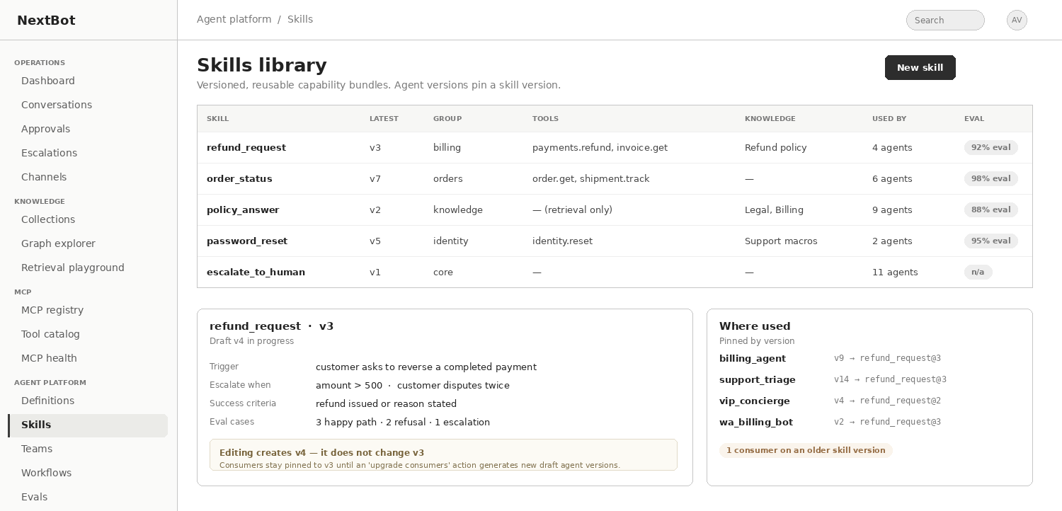
Figure 6 — Skills library with a where-used panel. Consumers stay pinned to the skill version they were composed with.
Pinning is what protects immutability
An agent version stores refund_request@3, never refund_request.
Editing a skill creates version 4 and leaves every existing agent version untouched.
The skill detail page offers an "upgrade consumers" action that generates new draft agent versions for each consumer, every one of which goes through the promotion gate normally.
Without this rule, editing a shared skill silently changes the behaviour of agents already approved and running in production.

8.2 The Agent Design Studio
The Studio is a third authoring mode alongside Text and Design, not a replacement for either. It must emit the same YAML, be validated by the same validator, and save the same immutable version. If the Studio can produce anything the schema cannot express, the architecture has been broken.
Step | Produces | Reuses
Purpose and persona | Name, role, tone, languages, explicit out-of-scope statements | —
Audience and channel | Declared trust level for this agent | Feeds the PII masking-context matrix
Skills | Composed skill list, pinned by version | Skills library
Tools | Capability groups and explicit allow/deny rules | The existing simulate preview from the tool permissions screen
Knowledge | Collection scopes, retrieval strategy, grounding policy | Module B
Guardrails and escalation | Thresholds, escalation triggers, output policy | Tenant PII and Guardrails settings
Model and budgets | Model routes and cost/latency ceilings | Model Gateway v2 routes
Memory | Memory strategy and retention window | —
Evals | A suite generated from the composed skills, editable | Eval suites
Review | Full YAML preview, then a Draft version | The same validator as Text and Design mode

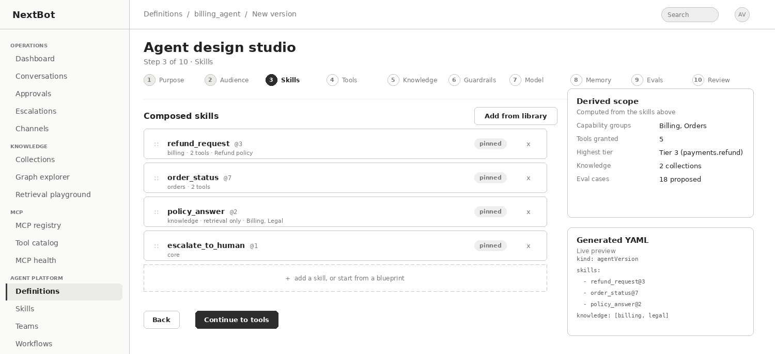
Figure 7 — Agent Design Studio, skills step. The derived scope panel shows what the composition actually grants, and the YAML preview shows what will be saved.

8.3 Two invariants the Studio must not break
- Tenant guardrails may be tightened by an agent version and never loosened. A version that relaxes tenant PII masking is rejected by the validator, not merely disabled in the interface.
- The Studio always lands in Draft. It never bypasses the eval, reviewer-not-author and sandbox gates. A wizard that produces production agents is how an unreviewed agent ends up talking to customers.
A blueprints gallery should sit alongside the Studio: pre-composed skill sets for common shapes such as support triage, order status and IT helpdesk, so a new tenant reaches a working Draft in minutes rather than authoring YAML cold.

8.4 Closing the eval gap
Eval suites today are hand-authored scripted mini-conversations with an expected-response pattern, a pass threshold and a cost budget, run to gate promotion. Four additions make them a quality system rather than a checkpoint.
Addition | Why
Harvest from production | A conversation, an escalation or a denied Tier-3 approval can be promoted into an eval case in one action. The highest-value eval source in the platform is already sitting in the Conversations list.
Continuous runs against production | Model routes point at external providers whose behaviour changes. A version that passed in March is not guaranteed to pass in August. Scheduled runs on the deployed version catch provider drift.
Rubric and judge grading | Expected-response pattern matching is brittle for generative output. A judge model scored against a rubric, plus groundedness and citation-precision metrics for retrieval agents, measures what actually matters.
Regression baselines | Gate on "no worse than the currently deployed version" rather than only on an absolute threshold, so a slow decline cannot pass repeatedly.

8.5 Diff and Git
Version comparison currently requires both versions to have a real Git commit, because it is a genuine Git-provider diff API call. But versions can be authored without ever connecting Git, so the majority path has no diff capability at all on a platform whose core artifact is a YAML document. The fix is to implement a structural YAML diff that works unconditionally and keep the Git diff as the enriched view when a repository is connected. This becomes more urgent, not less, once skills and workflow graphs are also YAML artifacts.
The one-Git-connection-per-tenant constraint should also be relaxed to one connection per definition or per team, since a large tenant with separate engineering groups cannot share a single repository across all agent definitions.

9. Module D — Workflow Designer

9.1 Static orchestration versus dynamic delegation
Two mechanisms are needed and they must not be conflated, because they require different governance. Static orchestration means the path is authored, reviewable and diffable before deployment: a human can look at the graph and know every route the system can take. Dynamic delegation, covered in §10, means a supervisor decides at runtime which specialist handles a turn — strictly more capable and strictly less predictable.
Because the platform's entire posture rests on reviewability, the rule is: use static orchestration whenever the process is knowable, and constrain dynamic delegation with declarative policy that is itself reviewable even though the path is not.

9.2 Node types
Node | Purpose | Notes
Trigger | Channel event, inbound webhook or schedule | A workflow may be bound to a channel exactly as an agent version is today
Agent | Invoke a pinned definition@version | The agent runs with its own scope, intersected with the workflow's
Skill | Invoke a single skill without a whole agent | Cheaper than a full agent turn for narrow tasks
Tool call | A deterministic MCP call with no model in the loop | Faster, cheaper and fully auditable — the right choice for "look up the order"
Router | Rule-based or classifier-based branch | Rules are preferred where the condition is expressible
Human task | Route into the existing Approval Queue or Escalation Queue | Never a third queue
Parallel / join | Fan out and reduce | Fan-out is capped by the run limits
Loop | Bounded iteration | A hard maximum-iteration cap is mandatory, not optional
Sub-workflow | Invoke another workflow version | Depth-capped
Wait | Timer or external event | Requires durable execution
End | Resolve, escalate or transfer | Terminal outcomes are explicit, never implicit

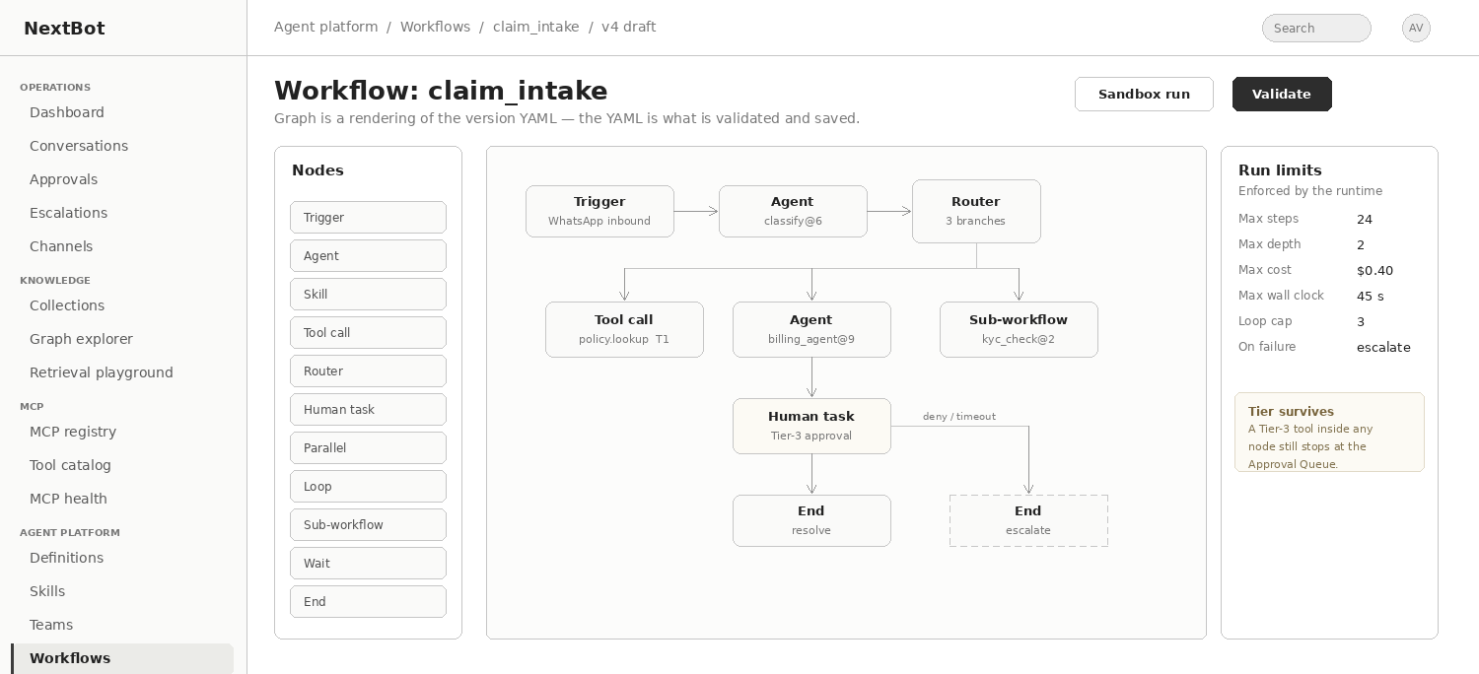
Figure 8 — Workflow canvas. The graph is a rendering of the version YAML; run limits are enforced by the runtime, not by the model.

9.3 Rules
Orchestration must not become a way around the existing controls
The graph is YAML. The canvas is a renderer, so workflows inherit immutability, diffability and the promotion gate for free.
The promotion gate applies unchanged: a passing eval run, an approver who is not the author, and at least one sandbox run of the whole graph — not of individual nodes.
Tool tiering survives orchestration. A Tier-3 tool invoked from inside any node still stops at the Approval Queue. This is the most likely way to accidentally undermine an existing control.
Every write-classified tool node declares an idempotency key and a compensating action, or the workflow is a distributed transaction with no rollback.

- Durable execution is required. A workflow suspended on a human task may sit for hours, so state must be checkpointed, resumable after a restart, and subject to a defined expiry behaviour.
- Run-level budgets — maximum steps, cost, wall-clock and loop iterations — are enforced by the executor.
- Runtime Traces render the executed path over the graph rather than as a flat list, and a separate trace viewer is not built.

9.4 Data model additions
Entity | Key fields
workflow | id, tenant_id, name, description, status
workflow_version | id, workflow_id, version, yaml, graph_json, status, created_by, approved_by, eval_run_id, sandbox_run_id
workflow_run | id, workflow_version_id, conversation_id, state, checkpoint_json, started_at, ended_at, cost_usd, outcome
workflow_run_step | id, run_id, node_id, node_kind, ref_version, started_at, ended_at, status, cost_usd, trace_span_id

10. Module E — Multi-agent orchestration

10.1 The central design move: agent as tool
The temptation is to build a second invocation path for delegation. The better decision is to register a specialist agent version as an entry in the Tool Catalog, with its own read/write classification and approval tier, exactly like an MCP tool.
That single decision buys almost everything. Delegation flows through the existing per-tool permission rules with their simulate preview. A specialist can be classified Tier 3, so a proposed hand-off lands in the Approval Queue with no new interface. The agent_tool_config module already controls whether a tool is visible to agents and its priority weight when several could serve the same request, which is precisely the routing-preference control a supervisor needs. And Runtime Traces already record tool calls with arguments and results, so a delegation is a trace entry by construction.
The alternative means duplicating tiering, permissions, audit and trace rendering, and those duplicates will drift apart.

10.2 Supported topologies
Pattern | When to use | Governance note
Supervisor and specialists | Triage into scoped domains | The default. The supervisor holds no tools of its own, only the ability to delegate
Sequential pipeline | Draft, then verify, then format | Belongs in the workflow graph, not in dynamic delegation
Parallel fan-out and reduce | Query several systems and merge | Hard fan-out cap and a shared run budget
Critic or verifier | A second agent checks the first agent's output | Cheap, high value, and pairs directly with the missing output-guardrail control
Peer hand-off | Full transfer of the conversation | Permitted only where the receiving agent's scope is a subset of the sender's

Free-form agent-to-agent messaging with no declared topology is explicitly not supported. It cannot be reviewed, cannot be capped, and produces an audit graph nobody can read.

10.3 Team definition
kind: team
name: support_team
version: 3
supervisor:
definition: triage@14
modelRoute: chat.router # routing is classification — do not spend a frontier model on it
members:
- definition: billing_agent@9
delegationTier: 2
invokeWhen: "billing, invoices, refunds, duplicate charges"
- definition: orders_agent@5
delegationTier: 1
- definition: policy_agent@4
delegationTier: 1
limits:
maxDepth: 2
maxFanOut: 3
maxDelegations: 6
runBudget: { usd: 0.40, seconds: 45 }
failureMode: escalate # never silently degrade

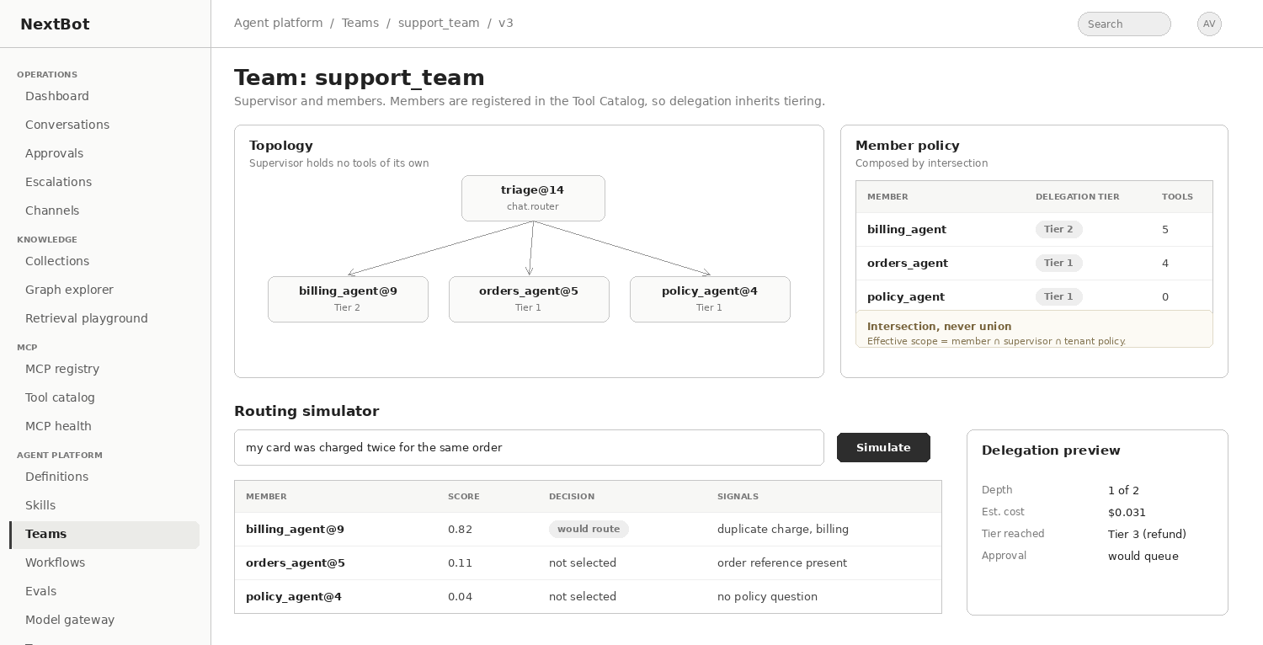
Figure 9 — Team definition with a routing simulator. Delegation preview shows depth, cost and the highest tier the route would reach before anything runs.

10.4 Six invariants the runtime must enforce
# | Invariant | Why it matters
1 | Permissions compose by intersection, never union. Effective scope equals member scope intersected with supervisor scope intersected with tenant policy. | Without this, a low-privilege supervisor delegating to a high-privilege specialist is a privilege-escalation primitive.
2 | Tier 3 survives every hop, and the Approval Queue displays the delegation chain that produced the request. | An approver looking at "refund 2,400" with no idea which agent asked, on whose behalf, cannot make a real decision — and this is the only human checkpoint.
3 | The PII masking-context matrix is re-evaluated at every agent boundary. | A hand-off is a context change. A supervisor holding unmasked PII passing a full transcript to a lower-trust specialist bypasses masking by composition.
4 | One conversation raises one escalation, against the parent, with the chain attached. | Two specialists tripping an escalation condition must not put the customer into two queues, and the takeover panel must show the whole tree.
5 | Budgets are shared and enforced at run level: depth, fan-out, delegation count, cumulative cost and wall-clock. | A supervisor that can re-delegate on failure is an unbounded loop unless the executor stops it.
6 | Members are pinned by version. | Promoting a member to a new version must not silently change a production team's behaviour after it was reviewed.

10.5 Extending the existing surfaces
Surface | Change required
Runtime Traces | Becomes a tree: which agent handled which span, the delegation reason, per-agent token and cost attribution, and the run total. Without it, a wrong answer in a three-agent run cannot be traced to the hop that produced it.
Conversations detail | Agent attribution on the transcript, with the reasoning trace collapsible per agent, so it is clear which agent produced each customer-visible message.
Audit Log | Actor attribution becomes a chain — "billing_agent@9, delegated by triage@14, on conversation 4471" — rather than a bare agent name.
Approval Queue | A delegation-chain panel and the policy context that caused the stop: tool tier, the guardrail that fired, the skill in play and the pinned manifest version.
Dashboard | Delegation metrics: routing accuracy, depth distribution, cost per resolved conversation and per-member escalation rate.
Evals | Two new case types — routing cases tested against the supervisor alone, and end-to-end team cases with an expected outcome and a budget ceiling. Routing regressions are the commonest multi-agent failure and the easiest to catch mechanically.
Sandbox | Runs the whole team in isolation with a visible delegation tree, since the promotion gate requires a completed sandbox conversation and a supervisor-only sandbox proves nothing.

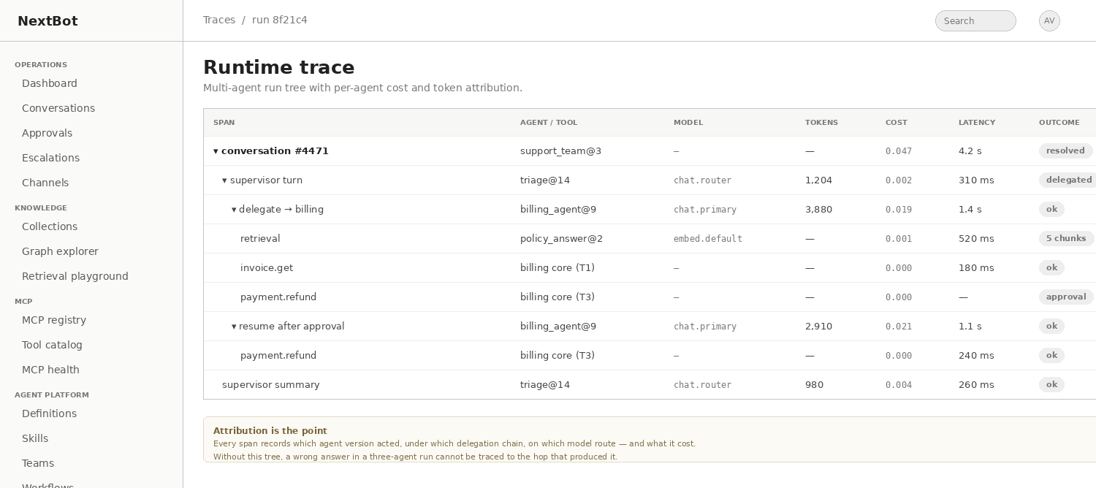
Figure 10 — Runtime trace as a tree, with per-agent model, token, cost and outcome attribution across a delegated run including an approval pause and resume.
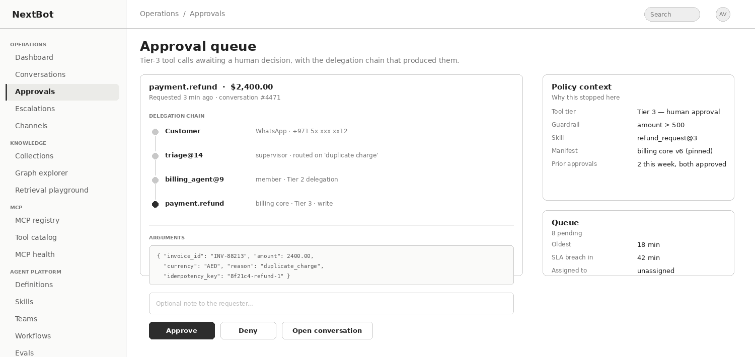
Figure 11 — Approval Queue with the delegation chain, arguments including an idempotency key, and the policy context that caused the stop.

10.6 Failure modes to design for
Failure | Mitigation
Routing thrash — the supervisor bounces between two specialists | Detect repeated delegation to the same member with a similar payload; cap and escalate
Context loss on hand-off — the specialist receives a summary that dropped the customer's actual constraint | Pass structured state through a conversation-scoped blackboard rather than a re-summarised transcript
Specialist unavailable — its pinned version was deprecated or its connector is offline | Declare a per-member fallback: another member, or escalate. Never silently answer without the specialist
Confidently wrong routing — a specialist without the right tools improvises | Specialists need an explicit "not mine" return path, treated as a first-class outcome in traces rather than as an error
Injection propagation — attacker-controlled tool output crosses an agent boundary and inherits the receiving agent's trust | Run output guardrails on tool results before they cross a delegation boundary, not only before they reach the customer

10.7 Data model additions
Entity | Key fields
team | id, tenant_id, name, description, status
team_version | id, team_id, version, supervisor_definition_version_id, limits_json, failure_mode, yaml, status, approved_by
team_member | id, team_version_id, definition_version_id, delegation_tier, invoke_when, fallback_member_id
delegation_event | id, conversation_id, run_id, parent_span_id, from_agent_version_id, to_agent_version_id, reason, depth, cost_usd, outcome

11. Module F — Model Gateway v2

11.1 Why the current design does not hold
The Model Gateway today has two tabs. Routes are the named targets an agent's modelRoute field points at, each a chain of one or more providers — either a platform-registered provider or a bring-your-own endpoint with its own credential — plus cache mode and timeout settings. Provider Registry is a read-only list of the platform-level providers available to route to. Model names typed into a route are lightly validated to catch obvious paste errors.
The shape is right; the abstraction is one layer short. A model is not a string. It has a context window, a maximum output, a price per million tokens in and out, a modality, a tokenizer family, a deprecation date, and a set of capabilities — tool calling, vision, streaming, structured output, extended thinking — that determine whether an agent version can even run on it. Because none of that is modelled, the platform cannot answer basic questions: whether a route can serve an agent that needs tool calling, what a conversation cost, which routes break when a provider retires a model, or whether a fallback hop would send data out of the tenant's region.

11.2 The three-layer model
Layer | Object | Owns
Provider | A connection to a model-serving endpoint | Provider type and adapter, base URL, authentication and vaulted credential, region, data-retention and training flags, organisation or project identifier, network reachability and egress policy, rate limits, health
Model | A catalogue entry belonging to a provider | Model identifier, display name, modality, context window, maximum output, capability flags, tokenizer family, price in and out, cached price, latency profile, status and deprecation date
Route | A named logical endpoint agents reference | An ordered chain of targets, each a provider plus model plus parameters, with failover conditions, retry and timeout, cache mode, weights, cost ceiling and residency constraints

11.3 Provider types
Provider type drives the adapter, not just the label. One openai-compatible type covers vLLM, TGI, LiteLLM and most self-hosted gateways, since they share a wire format and differ only in endpoint and authentication.
Provider type | Covers | Auth | Catalogue sync
anthropic | Anthropic API | API key | Static list plus API
openai | OpenAI API | API key | GET /v1/models
azure-openai | Azure OpenAI Service, regional deployments | API key or Entra ID | Deployment list
google-vertex | Vertex AI and AI Studio | Service account or API key | Publisher model list
bedrock | AWS Bedrock | IAM role or keys | Foundation model list
openrouter | OpenRouter as a meta-provider across many vendors | API key | GET /api/v1/models, then a tenant allowlist
openai-compatible | vLLM, TGI, LiteLLM, and any OpenAI-shaped endpoint | None, API key or mTLS | GET /v1/models
ollama | Local or on-premise Ollama | None | GET /api/tags
cohere / mistral / custom | Direct vendor APIs | API key | Vendor list or manual declaration

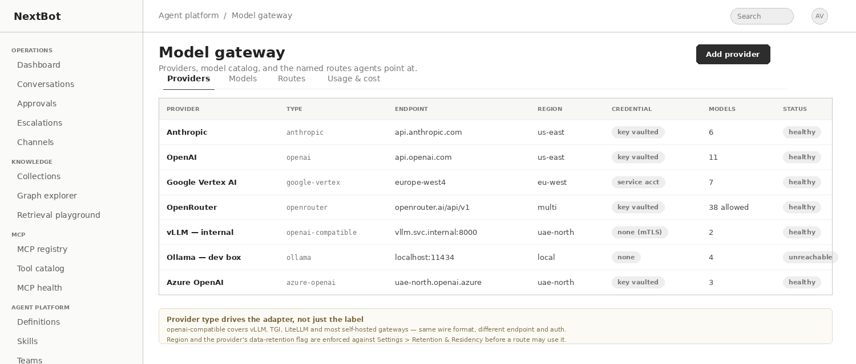
Figure 12 — Provider registry. Region and the provider's data-retention flag are checked against Settings > Retention and Residency before a route may use it.

11.4 The model catalogue
The catalogue replaces the free-text model name entirely. A route selects a catalogue entry; it never stores a typed string. Entries are synced from the provider where an API exists and declared manually for self-hosted deployments, and every entry carries the metadata that makes validation and cost reporting possible.
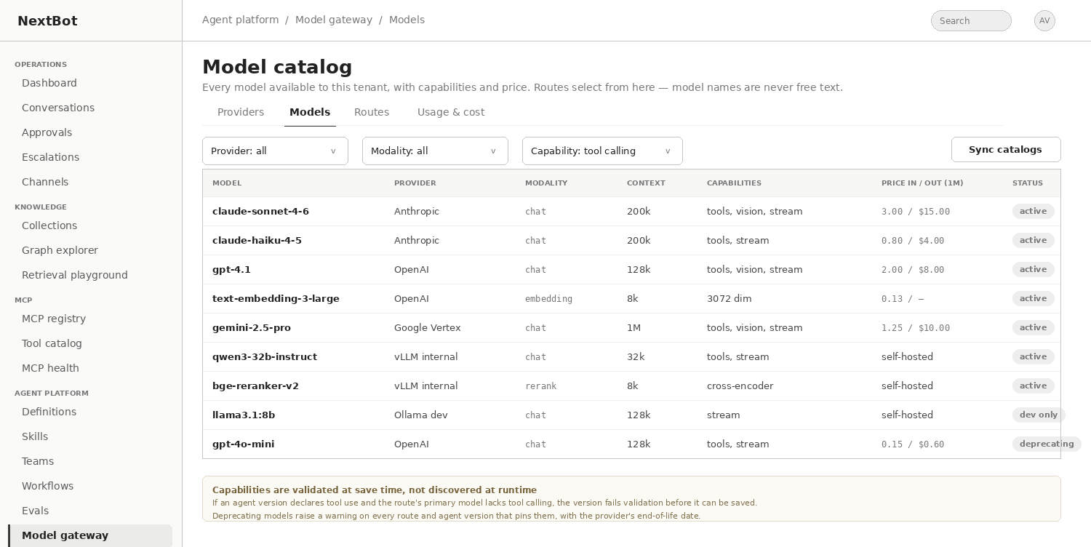
Figure 13 — Model catalogue across providers, including self-hosted vLLM and Ollama entries and an embedding and a rerank model.
Capability validation happens at save time, not at runtime
If an agent version declares tool use and the primary model on its route does not support tool calling, the version fails validation before it can be saved.
A route advertises only the capabilities that every hop in its chain supports — the weakest hop wins, because a fallback that silently drops tool calling is worse than a failure.
A model marked as deprecating raises a warning on every route and every agent version that pins it, with the provider's end-of-life date.

11.5 Routes
Routes remain the abstraction agents point at, and gain the policy that makes a fallback chain safe rather than merely present.
kind: modelRoute
name: chat.primary
version: 7
chain:
- provider: anthropic # 1 — primary
model: claude-sonnet-4-6
params: { temperature: 0.2, maxTokens: 4096 }
cache: ephemeral
- provider: azure-openai # 2 — fallback, same region as the tenant
model: gpt-4.1
failoverOn: [429, 5xx, timeout]
- provider: vllm-internal # 3 — last resort, self-hosted
model: qwen3-32b-instruct
setsDegradedFlag: true
policy:
allowOutOfRegionFailover: false
timeout: { perHop: 20s, total: 45s }
retry: { attempts: 2, backoff: exponential }
costCeilingPerTurn: 0.05
logPromptsToTraces: masked

- Recommended standard routes: chat.primary for answering, chat.router for classification and routing, embed.default for the knowledge index, rerank.default for retrieval reranking, and vision.default where images are handled.
- Routing on a cheap model and answering on a strong one is the single largest cost lever in a multi-agent system, and it is only expressible once routes are per-role rather than per-agent.
- Routes are versioned. An agent version pins route@version, so editing a route does not change the behaviour of an already-promoted agent.
- Failover semantics are declared, not implied: which error classes advance to the next hop, and whether a hop in another region is permitted at all. The default is that it is not.
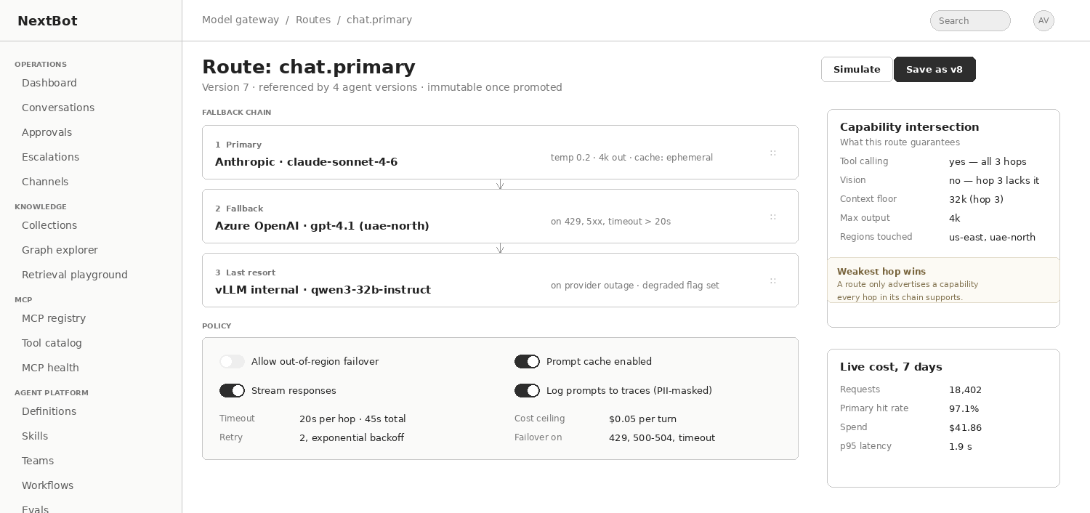
Figure 14 — Route editor with the fallback chain, policy, the capability intersection the route can guarantee, and live cost.

11.6 Usage, cost and the tenant view
Once providers, models and routes are modelled, usage telemetry becomes straightforward and closes gap G-11 directly. A usage tab should report spend and volume by provider, model, route, agent version and channel, with a cost-per-resolved-conversation figure that is the number a tenant actually cares about. Budget breach behaviour is declared at the route level — degrade to a cheaper hop, or fail — rather than being discovered when a limit is hit.

11.7 Governance and residency
Control | Rule
Plan-tier restriction | The Platform Manager console governs which provider types a plan tier may use, so a Starter tenant cannot attach an arbitrary bring-your-own endpoint if policy forbids it
Residency enforcement | A provider's region is checked against the tenant's storage region and out-of-region inference setting. A route whose chain would breach it cannot be saved
Data handling flags | Each provider records whether prompts are retained and whether they may be used for training. Routes surface the strictest flag in their chain
Credential handling | Provider credentials use the same encrypted vault as connectors and are never returned in plaintext
Self-hosted reachability | vLLM and Ollama providers need no credential but do need a reachability check, a concurrency limit and a health probe, since an unreachable local endpoint is a silent outage
Embedding model pinning | A knowledge index generation records the exact embedding provider and model. Changing it invalidates the index rather than silently mixing vector spaces

11.8 Data model additions
Entity | Key fields
model_provider | id, tenant_id (null for platform), type, name, base_url, region, auth_method, credential_ref, retains_prompts, trains_on_data, rate_limit_json, status
model_catalog_entry | id, provider_id, model_id, display_name, modality, context_window, max_output, capabilities_json, tokenizer, price_in, price_out, price_cached, status, deprecates_at
model_route | id, tenant_id, name, description
model_route_version | id, route_id, version, chain_json, policy_json, created_by, status
model_usage_event | id, tenant_id, route_version_id, catalog_entry_id, agent_version_id, conversation_id, tokens_in, tokens_out, cached_tokens, cost_usd, latency_ms, hop_index, outcome

12. Cross-cutting concerns

12.1 Permission composition
Every new module introduces a way for one artifact to reference another, and each reference is a place where scope could widen. The rule stated in §5.3 is repeated here because it must be implemented once, centrally, in the authorisation layer rather than separately in each module: effective scope is the intersection of the caller, the artifact and tenant policy. A workflow node, a delegated agent, a composed skill and a retrieval call all pass through the same evaluator.

12.2 Guardrails on the way out, not only on the way in
PII detection, the masking-context matrix and pre-tool-call blocking all act before something happens. Nothing acts on what comes back. Three additions are needed, and they become more urgent once tool output and retrieved content cross agent boundaries.
Guardrail | Applies to | Why
Prompt-injection detection | Inbound customer messages and, critically, tool results and retrieved chunks | A Fetch-class connector returns attacker-controlled text into model context. This is exploitable today and propagates across agents once delegation exists
Output policy | Agent responses before they reach the customer or cross a delegation boundary | Toxicity, off-topic drift, and disclosure of masked entities
Groundedness check | Responses from any agent with a knowledge scope | Enforces refuseWhenUngrounded rather than trusting the model to abstain

12.3 Rollback
This is the highest risk-to-effort item in the entire document. Promotion replaces the prior production deployment, and the only recovery path is Restore, which authors a new version that must then pass the full gate. The platform can deploy faster than it can recover.
Emergency rollback
Re-promote a previously-Production version directly, bypassing the gate on the grounds that it already passed the gate when it was first promoted.
Require a stated reason, write it to the audit log, and notify the tenant's administrators.
This is not a weakening of the promotion gate. It is a recognition that the gate has already been satisfied for that exact artifact, which is only true because versions are immutable.

Progressive rollout follows once rollback exists: traffic splitting on the channel-to-version binding, and shadow evaluation of a candidate version against live traffic without customer exposure.

12.4 Observability, export and recoverability
- OpenTelemetry export of traces and metrics, so a tenant can see NextBot spans alongside their own systems.
- Audit log streaming to a SIEM, which enterprise security teams will require and which cannot be retrofitted onto a console-only log.
- A consented break-glass path for platform operators. The cross-tenant health rollup is deliberately metadata-only, which is correct, but it leaves no way to diagnose a tenant-specific quality regression without the tenant's cooperation. Make that cooperation explicit, time-boxed and audited on both sides rather than absent.
- Configuration export and restore for a tenant's agents, skills, workflows, teams, connectors, routes and policies. Retention and Residency covers purge and region, not recoverability.

12.5 Escalation, workforce and channels
Escalation routing maps a goal and channel combination to a queue, and the detail page is a live takeover panel. Everything between "it landed in a queue" and "a human is holding it" is missing: assignment and claiming, SLA timers and aging, agent availability and presence, concurrency limits, and CSAT capture at the end of a takeover — which is also the natural feedback loop into evals. Routing to a queue nobody is watching is silent failure, and that is the current default.
On channels: two types exist, Web Widget and WhatsApp Business. The adjacent set — email, SMS, voice, Instagram and Messenger, Slack and Teams for internal use — needs a generalised channel abstraction so that adding a type is configuration rather than engineering. Cross-channel identity resolution matters more: the same customer on WhatsApp and on the web is currently two unrelated conversations with no shared context.

12.6 Identity and the developer surface
Gap | Requirement
SSO and SCIM | SAML and OIDC single sign-on, and SCIM provisioning. On a platform with an Enterprise tier, residency controls and a DSR screen, password plus TOTP is a procurement blocker independent of product quality
Session and key management | Session listing and revocation, service accounts and scoped API keys, and per-tenant password and MFA enforcement policy
Public API | Everything is console-driven today. Agent versions, skills, workflows and knowledge sources should be manageable programmatically
Webhooks | Outbound events for escalation created, approval pending, guardrail tripped, deployment changed and drift detected, so tenant systems can react

13. Delivery roadmap
Sequencing is driven by dependency and by risk, not by visible feature value. Three items in Phase 0 are small and prevent incidents that are currently unrecoverable.
Phase | Item | Rationale | Depends on
0 | Emergency rollback | The platform can deploy faster than it can recover. Highest risk-to-effort ratio in the document | —
0 | Capability-group management screen | Already referenced by the Design mode picker and unauthorable anywhere | —
0 | Manifest pinning and drift quarantine | Closes the clearest privilege-escalation path in the platform | —
0 | Injection guardrail on tool results | Exploitable today through the Fetch connector | —
0 | Structural YAML diff without Git | The majority authoring path has no diff at all | —
1 | Model Gateway v2 — providers, catalogue, routes, usage | Prerequisite for knowledge indexing and for per-role routing in teams | Phase 0
1 | MCP enrolment wizard and registry | Governs the tool supply chain the rest of the platform composes over | Manifest pinning
1 | Skills library with version pinning | The unit of composition everything above depends on | —
1 | SSO and SCIM | Gates enterprise deals regardless of the rest of the roadmap | —
2 | Knowledge and Graph RAG, retrieval agent, citations | The largest capability gap; needs a pinned embedding model | Model Gateway v2
2 | Agent Design Studio and blueprints | Composes skills; a wizard without skills is only a longer form | Skills
2 | Permission intersection evaluator and trace tree | Must ship before any delegation runs in production, not after | —
2 | Escalation SLA, assignment, presence and CSAT | Escalations exist but are not operable at scale | —
3 | Agent-as-tool registration and supervisor teams | Mostly registration and policy over machinery that already exists | Intersection evaluator, trace tree
3 | Workflow designer and durable runtime | The heavier of the two orchestration mechanisms | Skills, teams
3 | Eval harvesting, judge grading, continuous runs | Compounding quality gains once composition exists | Skills
4 | Progressive rollout, shadow evaluation, canary | Safe to build only once rollback and trace attribution exist | Phase 0, trace tree
4 | Public API, webhooks, OpenTelemetry and SIEM export | Integration parity in both directions | Stable module boundaries
4 | Channel expansion and cross-channel identity | Straightforward once the channel abstraction is generalised | —

Two ordering constraints that are not negotiable
Model Gateway v2 ships before the knowledge subsystem. A knowledge index pins an embedding model and cannot pin a free-text string.
The permission intersection evaluator and the trace tree ship before the first delegation runs in production. Retrofitting a permission model onto a live multi-agent system means auditing every existing team for escalation paths, and retrofitting attribution means the traces most needed for the first incident do not exist.

14. Risks and open decisions

14.1 Risks
Risk | Impact | Mitigation
Shared mutable artifacts break version immutability | A promoted agent silently changes behaviour after review, destroying the platform's strongest guarantee | Version-pin every reference at compose time; provide an explicit upgrade-consumers action that generates new drafts
Orchestration becomes a path around tool tiering | Tier-3 calls execute without human approval from inside a workflow node or a delegated agent | Enforce tiering in the tool executor, below the orchestration layer, and test it as a promotion gate case
Graph extraction quality is poor and invisible | Retrieval degrades in ways nobody can diagnose, and trust in the knowledge layer collapses early | Ship the graph explorer with provenance in the first release, plus retrieval evals measuring groundedness and citation precision
Multi-agent cost runs away | A supervisor plus three specialists plus retrieval can cost an order of magnitude more per conversation than a single agent | Per-role routes with a cheap router model, run-level budgets enforced by the executor, and cost-per-resolved-conversation on the dashboard from day one
The Studio outpaces the schema | Authoring surfaces diverge and the YAML stops being the single source of truth | One validator, and a test that asserts every Studio output round-trips through Text mode unchanged
Provider catalogue drift | Models are retired by providers and routes fail in production | Scheduled catalogue sync, deprecation warnings on every referencing route and agent version, and a declared fallback chain
Scope creep across six modules | Nothing reaches production quality | Phase 0 is five small items that stand alone; each later phase has a single load-bearing dependency and can ship independently

14.2 Decisions required before build
- Graph store: a dedicated graph database, or graph tables plus a vector index in the existing store. The second is simpler operationally and sufficient at the scale implied by the current tenant model; the first is easier if multi-hop traversal depth grows.
- Whether teams and workflows are two artifacts or one. This document proposes two, because their governance differs, but a single artifact with a mode flag is defensible and reduces surface area.
- Whether skills are tenant-scoped only, or whether a platform-level blueprint library is shared across tenants. Sharing creates a cross-tenant supply-chain question that the current isolation model does not have.
- Whether the knowledge subsystem indexes conversation history as a source. It is valuable and it interacts directly with retention, DSR deletion and the masking matrix.
- How far the Platform Manager console governs provider types per plan tier, given that bring-your-own endpoints are a stated capability today.
- Whether routing decisions in a team are recorded as a customer-visible event. They are useful in the takeover panel and they expose internal structure.

Appendix A — Wireframe index
All wireframes are indicative layouts intended to fix information architecture and the placement of controls, not visual design. They deliberately reuse the existing console chrome, sidebar grouping and read-only affordances described in the Screen Reference.
Figure | Screen | Section | File
1 | MCP registry list | — | wf01-mcp-registry.png
2 | Enrolment wizard, discovery and classification step | — | wf02-mcp-enrolment.png
3 | Knowledge collections with the ingestion pipeline for one collection | — | wf03-knowledge-collections.png
4 | Graph explorer with an entity inspector | — | wf04-graph-explorer.png
5 | Retrieval playground comparing three strategies on one query, with groundedness, latency and cost per strategy | — | wf05-retrieval-playground.png
6 | Skills library with a where-used panel | — | wf09-skills-library.png
7 | Agent Design Studio, skills step | — | wf10-studio-wizard.png
8 | Workflow canvas | — | wf11-workflow-canvas.png
9 | Team definition with a routing simulator | — | wf12-team-routing.png
10 | Runtime trace as a tree, with per-agent model, token, cost and outcome attribution across a delegated run including an approval pause and resume | — | wf13-trace-tree.png
11 | Approval Queue with the delegation chain, arguments including an idempotency key, and the policy context that caused the stop | — | wf14-approval-delegation.png
12 | Provider registry | — | wf06-model-providers.png
13 | Model catalogue across providers, including self-hosted vLLM and Ollama entries and an embedding and a rerank model | — | wf07-model-catalog.png
14 | Route editor with the fallback chain, policy, the capability intersection the route can guarantee, and live cost | — | wf08-route-editor.png

Appendix B — Glossary
Term | Definition
Agent definition | The named, versioned identity a channel talks to, with a history of versions underneath it
Agent version | An immutable YAML document describing model route, instructions, tool policy, guardrails, memory strategy, eval suite and budgets
Capability group | A named, curated set of tools drawn from one or more MCP servers, selectable when scoping an agent version
Community | A cluster of related entities in the knowledge graph, summarised so that broad questions can be answered without reading every chunk
Delegation chain | The ordered record of which agent invoked which, used for audit attribution and for approval context
Groundedness | The proportion of an answer supported by retrieved evidence; used as an eval metric and as a runtime refusal condition
Manifest | The hashed snapshot of the tools, resources and prompts an MCP server exposed at the moment it was approved
Promotion gate | The three conditions required to reach Production: a passing eval run, an approver who is not the author, and a completed sandbox conversation
Route | A named logical model endpoint, backed by an ordered chain of provider-and-model targets with failover policy
Skill | A versioned bundle of one capability: trigger, scope, instructions, success criteria, escalation conditions and eval cases
Team | A supervisor agent plus scoped member agents, with delegation limits and a failure mode
Tier 1 / 2 / 3 | Tool approval tiers: executed automatically, executed and logged, and held for human approval respectively
Workflow | A versioned orchestration graph of triggers, agents, tools, routers, human tasks and terminal outcomes

